Final Year Project Technical Report
BSc Computing



NLP-Driven Financial Document Pre-Review and Anomaly Detection

Oisin Gibson
L00172671

Declaration

- I have accurately identified and included the sources of all facts, ideas, opinions, and viewpoints from others in the assignment references. All direct quotations, paraphrasing, and discussions of ideas from books, journal articles, internet sources, course materials, or any other sources used are properly acknowledged and cited in the assignment references.
- I have not used unauthorised artificial intelligence tools or aids.
- I understand and am compliant with ATU's policy and procedures regarding Academic Integrity and I am aware of the consequences of any violations.
- I have followed the referencing guidelines recommended in the assignment instructions and / or programme documentation.
- I understand that not adhering to the word limits on each section will result in penalties.
- By signing this form or by submitting material online I confirm that this assignment, or any part of it, has not been previously submitted by me or any other person for assessment on this or any other programme of study.
- By signing this form or by submitting material for assessment online I confirm that I have read and understood AQAE022 Academic Integrity Policy.

I confirm I agree to this declaration. ☒

Print Signature: Oisin Gibson

Date:

Acknowledgements
I would like to thank my supervisor Dr Kevin Meehan for his support and guidance over the course of the project in his role as project supervisor. In addition, I would like to offer my thanks to Robbie Quinn, CEO Helix Partnership LTD, for stepping into the role of gatekeeper for the project.

Table of Contents
1. Project Overview 1
1.1. Purpose 1
1.2. Objectives 1
1.2.1. Specific objectives 1
1.3. Project Scope 2
1.3.1 In Scope 2
1.3.2 Out of Scope 3
2. Requirements 4
2.1. Functional Requirements 4
2.2. Non-Functional Requirements 10
2.3. Data Processing Summary 13
3 System Architecture & Design 14
3.1 Hardware and Software Requirements 14
3.2 High-Level System Architecture 14
3.2.1 Presentation Layer 15
3.2.2 Application Layer 15
3.2.3 Analytical Layer 16
3.3 Key Components, Functions, and Interactions 17
3.4 Description of System Features and Workflows 18
3.5 Design and Implementation Constraints 23
3.6 System Qualities 23
3.6.1 Maintainability 23
3.6.2 Extensibility 23
3.6.3 Scalability 24
3.7 Security Protocols and Considerations 24
3.8 Testing Strategy 24
4 Data Requirements 27
4.1 Data Sources and Characteristics 27
4.2 Data Model and Schema 27
4.3 Data Storage Requirements 29
4.4 Data Flow 30
4.5 Data Volume and Performance Constraints 31
4.6 Data Privacy, Ethics, and Security Requirements 31
4.7 Data Quality Requirements 32
5 Implementation 33
5.1 Implementation Approach and Development Methodology 33
5.2 Development Environment and Tools 33
5.3 Planned Codebase Structure 36
5.4 Step-by-step Implementation Plan 37
5.4.1 Sprint 1 – Project Setup, Architecture Scaffolding, and Authentication 37
5.4.2 Sprint 2 – Document Upload, File Handling, and Extraction Pipeline 38
5.4.3 Sprint 3 – Core NLP Pre-processing, Topic Modelling, and NER 39
5.4.4 Sprint 4 – Summarisation, Anomaly Detection, and Explainability 40
5.4.5 Sprint 5 – Testing, Refinement, and Project Consolidation 40
5.5 Deployment and Runtime Strategy 42
5.5.1 Local deployment 42
5.5.2 Cloud Deployment 42
5.6 Privacy, Security, and Data Governance 43
5.7 Error Handling and System Observability 43
5.8 Testing Strategy 44
6 Testing & Evaluation 45
7 Conclusion 47
8 References i
9 Appendix A: Report Structure Example iv
10 Appendix B: Code Listing / GitHub Project Link vi

Table of Figures
Figure 1 Use Case Diagram 12
Figure 2 Component Diagram 13
Figure 3 High Level Diagram 17
Figure 4 Activity Diagram 22
Figure 5 Class Diagram 25
Figure 6 Sequence Diagram 26
Figure 7 Entity Relationship Diagram 29
Figure 8 Data Flow Diagram 31
Figure 9 React Imports 34
Figure 10 ARIA label 34
Figure 11 Password Hashing 34
Figure 12 NER Function 35
Figure 13 File Structure 37
Figure 14 Project Board 41
Figure 15 Package File 42
Figure 16 Document Deletion 43
Figure 17 Document Upload 44
Figure 18 Text Extraction Error Catching 44

Glossary of Terms
Term | Definition
Artificial Intelligence (AI) | The development of computer systems that can perform tasks that typically require human intelligence, such as learning, problem-solving, and decision-making.
Portable Document Format (PDF) | A file format for capturing and sending electronic documents in exactly the intended format
Natural Language Processing (NLP) | A field of artificial intelligence and computer science that enables computers to understand, interpret, and generate human language.
Tokenisation | A fundamental step in Natural Language Processing (NLP) that breaks down text into smaller units called "tokens," such as words, sub words, or characters
Stopword removal | A text pre-processing technique that involves deleting common but uninformative words like "the," "is," and "a" from a body of text
Lemmatization | A natural language processing (NLP) technique that reduces a word to its base or dictionary form, called a lemma.
Term Frequency-Inverse Document Frequency (TF-IDF) | A statistical measure in Natural Language Processing (NLP) used to evaluate how important a word is to a document within a collection (corpus)
Latent Dirichlet Allocation (LDA) | An unsupervised machine learning technique used for topic modelling, which automatically discovers the hidden thematic structure in a collection of documents
BERTopic | An advanced, unsupervised topic modelling technique that leverages modern transformer models (like BERT) and a class-based variation of the TF-IDF algorithm (c-TF-IDF) to create dense, easily interpretable, and high-quality topics
Name Entity Recognition (NER) | A key technique in Natural Language Processing (NLP) that automatically identifies and classifies important information, known as "named entities," within unstructured text into predefined categories.
TextRank | A general-purpose graph-based ranking algorithm in NLP.
ROUGE-1 | Measures the overlap of unigrams (single words) between a machine-generated summary and a human-written reference summary.
Bilingual Evaluation Understudy (BLEU) | A metric which is used to evaluate the quality of machine-generated text by comparing it to one or more reference texts.
Optical Character Recognition (OCR) | A technology which converts images of text into machine readable and editable text. Used to scan documents or handwritten text which allows the user to search, edit or copy the previously static content.
General Data Protection Regulation (GDPR) | European Union law that protects an individual’s personal data and harmonizes data privacy laws across EU countries.
Hypertext Transfer Protocol Secure (HTTPS) | The secure version of HTTP which encrypts the data transmitted between the user’s browser and a website.

Project Overview

Purpose
Financial document analysis is a crucial function when it comes to maintaining accuracy and trust within the financial and auditing sectors. However, much of this data still comes in unstructured formats such as Portable Document Format (PDFs), Word documents and spreadsheets. This results in workplace professionals having to manually review the files to identify anomalies. This process is not only time-consuming but prone to human error and inefficient at a large scale.
The aim of this project is to design and implement a web-based Natural Language Processing (NLP) system which will automate the extraction and analysis of financial documents at the earliest stages of reviews. The system will use techniques such as NLP, Named Entity Recognition (NER) and extractive summarisation to process the uploaded files and generate concise summaries while also highlighting potential anomalies.
The system aims to assist the workplace professionals with correctly identifying key insights and anomalies. This should in theory reduce the workload while also improving consistency, accuracy and efficiency in financial document analysis.

Objectives
The main aim of this project is to build a system that will demonstrate how NLP can be used to automate this early-stage review of financial documents. The core functionally will see the system extract, summarise and analyse financial documents while also flagging potential anomalies for further investigation.

Specific objectives
- Text Extraction: Have the system be able to extract readable text from PDF, DOCX and XLSX files.
- Pre-processing: Implement tokenisation, stopword removal, and lemmatisation with a processing time averaging under two seconds per document.
- Topic Modelling: Identify the core financial topics using TF-IDF and LDA. Evaluate BERTopic as an alternative.
- Entity Recognition: Detect key financial entities and relationships within the documents using NER.
- Summarisation: Implement TextRank in order to extract summaries from the documents. Access the performance using ROUGE and BLEU metrics.
- Anomaly Detraction: Flag anomalies detected by developing a rule-based module. Anomalies will be assigned traffic-light rating (Green, Amber, Red).
- System Integration: Develop a prototype with a frontend using React and Node.js/Express for the backend. JWT will be used for user authentication.
- User Usability: Conduct a user experience test with the aims of achieving 80% satisfaction rating in regard to usability and relevance.

Project Scope
The project will focus on the development of a functional prototype of a web-based application that implements NLP functionality. The aim of this prototype is to automate the early-stage review of financial data. Various key modules will be implemented to perform text extraction, summarisation, and anomaly detection. The theory is that this process will enable efficient and scalable analysis of financial documents.
The system will also implement authentication and robust handling of the financial data which ensures privacy and compliance.
To evaluate the effectiveness and performance of the NLP components, established metrics will be employed. Summarisation quality will be measured using Bilingual Evaluation Understudy (BLEU) and Recall-Oriented Understudy for Gisting Evaluation (ROUGE) scores while the anomaly detection features will be measured using precision, recall and accuracy. BLEU is a widely used metric that is used to assesses the overlap of n-grams between generated and reference texts. The metric was originally introduced by Papineni. (Papineni et al., 2002a). The ROUGE metric, developed by Lin, complements BLEU by focusing on recall-based comparisons. (Lin, 2004) .This is particularly effective for the summarisation tasks in this system.

1.3.1 In Scope
- Development of a functional prototype.
- Implement NLP-based modules for the text extraction, summarisation, and anomaly flagging features.
- Secure user authentication and handling of the financial data.
- Evaluate the NLP performance using pre-established NLP metrics.

1.3.2 Out of Scope
- Advanced deep learning models.
- Full-scale financial auditing or reporting generation.
- Real-time deployment in a production environment.
- Analysis of sensitive, non-anonymous financial data.
The system will be developed using anonymised datasets, provided by Helix Innovation Partnerships Ltd. The datasets will be processed within a secure environment within Microsoft Azure to ensure privacy and ethical compliance.

Requirements
This section of the report outlines the functional and non-functional requirements of the system. The different requirements for the project were derived from the literature on Section 1 and from the technical constraints covered during the planning stage. The functional requirements specify what the system must do, while non-functional requirements specify the quality attributes and operational standards the system must achieve. Paired together they provide the foundation for the design, implementation, and evaluation of the system.

Functional Requirements
FR1 - User Authentication
Secure authentication mechanism will be implemented within the system using bcrypt for password hashing and JSON Web Tokens (JWT) for session control. This process ensure that only authorised users are able to upload and analyse financial documents. By using industry-standard authentication, the project aligns with GDPR compliance and best practices for web security. (mrbullwinkle, 2025a).
FR2 - Document Upload and Management
System users will be able to upload financial documents in multiple formats, including PDF, DOCX, and XLSX. Once uploaded, these files will be processed through a secure API endpoint and temporarily stored within a Microsoft Azure environment. This functionality ensures the system can seamlessly accommodate the diverse data formats commonly encountered in financial analysis workflows, enhancing both flexibility and efficiency. (Hegghammer, 2022a).
Code Listing 1 PDF Upload Function
print("Please upload your financial document (PDF):")
/**
* POST /api/documents/upload
* Upload a PDF document
*/
router.post('/upload', auth, upload.single('document'), async (req, res) => {
try {
// Check if a file was actually uploaded
if (!req.file) {
return res.status(400).json({ error: 'No file uploaded' });

}

// Set expiry date (6 months from now) May end up chaning depending on what Helix says
const expiresAt = new Date();
expiresAt.setMonth(expiresAt.getMonth() + 6); // Set expiration to 6 months from now

// Create database record for the uploaded file
const document = await Document.create({
originalName: req.file.originalname, // User's filename
filename: req.file.filename, // Our unique filename
filePath: req.file.path, // Full path on server
fileSize: req.file.size, // Size in bytes
userId: req.user.id, // Who uploaded it
uploadDate: new Date(), // When it was uploaded
expiresAt // Expires in 6 months
});

// Start NLP processing in the background (async, don't wait)
processDocumentNLP(document);

// Send response immediately
res.status(201).json({
message: 'Document uploaded successfully',
document: {
id: document.id,
originalName: document.originalName,
fileSize: document.fileSize,
uploadDate: document.uploadDate,
nlpProcessed: false // Processing just started
}
});

} catch (error) {
// If database save fails, clean up the uploaded file
if (req.file && fs.existsSync(req.file.path)) {
fs.unlinkSync(req.file.path);
}
console.error('Upload error:', error);
res.status(500).json({ error: 'Failed to upload document' });
}
});

if not uploaded:
raise SystemExit("No file uploaded. Please run the cell again and upload a PDF.")

pdf_path = list(uploaded.keys())[0]
print("Using file:", pdf_path)

// Set expiry date (6 months from now) May end up chaning depending on what Helix says
const expiresAt = new Date();
expiresAt.setMonth(expiresAt.getMonth() + 6); // Set expiration to 6 months from now
// Create database record for the uploaded file
const document = await Document.create({
originalName: req.file.originalname, // User's filename
filename: req.file.filename, // Our unique filename
filePath: req.file.path, // Full path on server
fileSize: req.file.size, // Size in bytes
userId: req.user.id, // Who uploaded it
uploadDate: new Date(), // When it was uploaded
expiresAt // Expires in 6 months
});
// Start NLP processing in the background (async, don't wait)
processDocumentNLP(document);
// Send response immediately
res.status(201).json({
message: 'Document uploaded successfully',
document: {
id: document.id,
originalName: document.originalName,
fileSize: document.fileSize,
uploadDate: document.uploadDate,
nlpProcessed: false // Processing just started
}
});

} catch (error) {
// If database save fails, clean up the uploaded file
if (req.file && fs.existsSync(req.file.path)) {
fs.unlinkSync(req.file.path);
}
console.error('Upload error:', error);
res.status(500).json({ error: 'Failed to upload document' });
}
});

console.error('Upload error:', error);
res.status(500).json({ error: 'Failed to upload document' });
}
});

FR3 – Text Extraction
The system will be able to extract machine-readable text from the uploaded financial documents. This will be accomplished using a combination of parsing and Optical Character Recognition (OCR) techniques. For proof-of-concept testing, Google Colab will be used to validate the functionality and performance of the workflow. Depending on usability in terms of the reach of this project, Azure Form Recognizer or Apache Tika will be employed for text extraction. This will ensure that tabular and multi-column content is accurately captured. This is an essential process for handling unstructured financial documents, often which contain embedded table or footnotes. (Hegghammer, 2022a).

Code Listing 2 Text Extraction Function
export async function extractTextFromPDF(filePath) {
// ATTEMPT 1: Try normal text extraction
const rawText = await extractTextWithTika(filePath);
const validation = validateExtractedText(rawText);

// Check if the extracted text is good enough
if (!validation.ok) {
// If not, try OCR (for scanned documents or images)
console.warn(`Text extraction validation failed, attempting OCR fallback: ${validation.reason}`);

// ATTEMPT 2: Try with OCR enabled
const ocrText = await extractTextWithTika(filePath, {
ocr: true,
ocrStrategy: 'ocr_and_text'
});
const ocrValidation = validateExtractedText(ocrText);

// Check if OCR text is good
if (ocrValidation.ok) {
console.log('OCR extraction successful');
return ocrText;
}

// ATTEMPT 3: Force OCR-only (for image-only/scanned PDFs)
console.warn('OCR extraction failed, attempting forced OCR-only extraction...');
const forcedOcrText = await extractTextWithTika(filePath, {
ocr: true,
ocrStrategy: 'ocr_only'
});
const forcedOcrValidation = validateExtractedText(forcedOcrText);
if (forcedOcrValidation.ok) {
console.log('Forced OCR-only extraction successful');
return forcedOcrText;
}

// ATTEMPT 4: Try alternative extraction method
// This uses special Tika features to extract inline images
console.warn('Forced OCR-only extraction failed, attempting alternative extraction method...');
let altValidation;
try {
const altText = await extractTextWithTika(filePath, { alternative: true });
altValidation = validateExtractedText(altText);

// Check if alternative extraction worked
if (altValidation.ok) {
console.log('Alternative extraction successful');
return altText;
}

// If validation failed with a specific reason (like image detection), use that
if (altValidation && altValidation.reason) {
throw new Error(altValidation.reason);
}
} catch (altError) {
// Alternative method failed (likely Tika configuration issue or corrupted PDF)
console.warn(`Alternative extraction failed: ${altError.message}`);
// If this is a validation error with a specific message, re-throw it
if (altError.message.includes('images but no extractable text') ||
altError.message.includes('re-create the document')) {
throw altError;
}
}

// All three attempts failed - provide detailed error message
const trimmedRawText = (rawText || '').trim();
const trimmedOcrText = (ocrText || '').trim();

// Check if PDF returned only whitespace (common with graphics-based PDFs)
if (trimmedRawText.length === 0 && trimmedOcrText.length === 0) {
throw new Error(`Unable to extract any readable text from this PDF. The document contains only whitespace/blank content. This typically happens when:\n\n1. Text is rendered as vector graphics or flattened images (not actual text)\n2. The PDF uses custom fonts that aren't properly embedded\n3. The document is corrupted or encrypted\n\nSuggested solutions:\n• Re-export the PDF with "Embed all fonts" and "Preserve text" options enabled\n• Try converting to Word format first, then save as a new PDF\n• Use OCR software to create a searchable PDF from the original\n• Verify the PDF opens correctly and text can be selected/copied in a PDF reader`);
}

// If we got some text but not enough, provide different guidance
throw new Error(`Unable to extract sufficient text from this document (${trimmedRawText.length} characters extracted). This may occur with scanned images, blank pages, very short documents, or PDFs with text rendered as graphics. Please ensure your PDF contains readable text content.`);
}

// Return the successfully extracted text
return rawText;
}

narrative_rows.append({
"section": section,

"value_current": current_val,
"value_prior": prior_val,
"names": ", ".join(extract_names(s_clean)),
"dates": ", ".join(extract_dates(s_clean))
})

df_narrative = pd.DataFrame(narrative_rows)
print(f"Narrative sentences extracted: {len(df_narrative)} rows.")

print("\nExtracting narrative sentences from OCR text...")

full_text = "\n".join(page_texts)
sentences = sent_tokenize(full_text)

narrative_rows = []

for s in sentences:
s_clean = s.replace("\x0c", " ").strip() # remove strange page-break characters
if not s_clean:
continue

section = classify_section(s_clean)
nums = extract_financial_numbers(s_clean)

current_val = nums[0][1] if len(nums) > 0 else ""
prior_val = nums[1][1] if len(nums) > 1 else ""

if (ocrValidation.ok) {
console.log('OCR extraction successful');
return ocrText;
}

// ATTEMPT 3: Force OCR-only (for image-only/scanned PDFs)
console.warn('OCR extraction failed, attempting forced OCR-only extraction...');
const forcedOcrText = await extractTextWithTika(filePath, {
ocr: true,
ocrStrategy: 'ocr_only'
});
const forcedOcrValidation = validateExtractedText(forcedOcrText);
if (forcedOcrValidation.ok) {
console.log('Forced OCR-only extraction successful');
return forcedOcrText;
}
// ATTEMPT 4: Try alternative extraction method
// This uses special Tika features to extract inline images
console.warn('Forced OCR-only extraction failed, attempting alternative extraction method...');
let altValidation;
try {
const altText = await extractTextWithTika(filePath, { alternative: true });
altValidation = validateExtractedText(altText);

// Check if alternative extraction worked
if (altValidation.ok) {
console.log('Alternative extraction successful');
return altText;
}

// If validation failed with a specific reason (like image detection), use that
if (altValidation && altValidation.reason) {
throw new Error(altValidation.reason);
}
} catch (altError) {
// Alternative method failed (likely Tika configuration issue or corrupted PDF)
console.warn(`Alternative extraction failed: ${altError.message}`);
// If this is a validation error with a specific message, re-throw it
if (altError.message.includes('images but no extractable text') ||
altError.message.includes('re-create the document')) {
throw altError;
}
}

// All three attempts failed - provide detailed error message
const trimmedRawText = (rawText || '').trim();
const trimmedOcrText = (ocrText || '').trim();

// Check if PDF returned only whitespace (common with graphics-based PDFs)
if (trimmedRawText.length === 0 && trimmedOcrText.length === 0) {
throw new Error(`Unable to extract any readable text from this PDF. The document contains only whitespace/blank content. This typically happens when:\n\n1. Text is rendered as vector graphics or flattened images (not actual text)\n2. The PDF uses custom fonts that aren't properly embedded\n3. The document is corrupted or encrypted\n\nSuggested solutions:\n• Re-export the PDF with "Embed all fonts" and "Preserve text" options enabled\n• Try converting to Word format first, then save as a new PDF\n• Use OCR software to create a searchable PDF from the original\n• Verify the PDF opens correctly and text can be selected/copied in a PDF reader`);
}

// If we got some text but not enough, provide different guidance
throw new Error(`Unable to extract sufficient text from this document (${trimmedRawText.length} characters extracted). This may occur with scanned images, blank pages, very short documents, or PDFs with text rendered as graphics. Please ensure your PDF contains readable text content.`);
}

// Return the successfully extracted text
return rawText;
}

narrative_rows.append({
"section": section,
"text": s_clean,
"value_current": current_val,
"value_prior": prior_val,
"names": ", ".join(extract_names(s_clean)),
"dates": ", ".join(extract_dates(s_clean))
})

df_narrative = pd.DataFrame(narrative_rows)
print(f"Narrative sentences extracted: {len(df_narrative)} rows.")

throw new Error(altValidation.reason);
}
} catch (altError) {
// Alternative method failed (likely Tika configuration issue or corrupted PDF)
console.warn(`Alternative extraction failed: ${altError.message}`);
// If this is a validation error with a specific message, re-throw it
if (altError.message.includes('images but no extractable text') ||
altError.message.includes('re-create the document')) {
throw altError;
}
}

// All three attempts failed - provide detailed error message
const trimmedRawText = (rawText || '').trim();
const trimmedOcrText = (ocrText || '').trim();

// Check if PDF returned only whitespace (common with graphics-based PDFs)
if (trimmedRawText.length === 0 && trimmedOcrText.length === 0) {
throw new Error(`Unable to extract any readable text from this PDF. The document contains only whitespace/blank content. This typically happens when:\n\n1. Text is rendered as vector graphics or flattened images (not actual text)\n2. The PDF uses custom fonts that aren't properly embedded\n3. The document is corrupted or encrypted\n\nSuggested solutions:\n• Re-export the PDF with "Embed all fonts" and "Preserve text" options enabled\n• Try converting to Word format first, then save as a new PDF\n• Use OCR software to create a searchable PDF from the original\n• Verify the PDF opens correctly and text can be selected/copied in a PDF reader`);
}
// If we got some text but not enough, provide different guidance
throw new Error(`Unable to extract sufficient text from this document (${trimmedRawText.length} characters extracted). This may occur with scanned images, blank pages, very short documents, or PDFs with text rendered as graphics. Please ensure your PDF contains readable text content.`);
}
// Return the successfully extracted text
return rawText;
}

FR4 – Text Pre-Processing
After the text has been extracted the system will then prepare the data for downstream NLP tasks. This will be accomplished by applying methods such as tokenisation, stopword removal, and lemmatisation. The pipeline used for pre-processing shall be optimised to achieve an average processing time of under two seconds per document. To prevent the removal of any key financial terms, domain-aware token retention will be implemented. (InstituteAdmin, 2025a). The token retention will be looking out for terms such as balance or equity. (Lu and Huo, 2025).
FR5 - Topic Modelling
Using Term Frequency-Inverse Document Frequency (TF-IDF) and Latent Dirichlet Allocation (LDA), the system will be able to identify dominant financial themes within the documents. If resources allow, BERTopic will be used as an alternative for a more semantically coherent clustering. (Zvornicanin, 2022a). The process of topic modelling will provide insight into recurring subjects and anomalies that may require further evaluation.
FR6 – Named Entity Recognition (NER)
NER is the process which will be implemented to identify key financial entities. Such entities may be the company name, monetary amounts, dates or reporting periods. The module will use fine-tuned corpora to ensure high precision and recall. (Shah et al., 2024a). The entity recognition aspect will convert the unstructured text into structured data. This data can then be cross-referenced and validated by the system.
FR7 - Summarisation
The TextRank algorithm will be employed to provide extractive summaries of the uploaded financial documents. Rather than use abstractive methods to preserve factual and numerical accuracy, summarisation was instead chosen. This is essential for regulatory contexts. (Chae et al., 2024). BLEU and ROUGE metrics will later be used to evaluate the quality of the summarisation. (Papineni et al., 2002b; Lin, 2004).
FR8 – Anomaly Detection
Using a rule-based anomaly detection module, potential irregularities in the data will be flagged for review. Each of the documents will be categorised using a pre-established traffic-light system.
- Green being normal
- Amber being review
- Red being critical
Using this approach will enable interpretable and transparent anomaly scoring. (PricewaterhouseCoopers, 2023a).
FR9 – User Interface and Feedback Logging
Using React, a dashboard will display the various document summaries, key topics and the anomaly scores. The system will allow the users to review the flagged sections and provide feedback on said sections. The collected feedback will the be used to measure the usability of the system and further be used guide improvements. (Peerdh, 2023).

Non-Functional Requirements
NFR1 – Performance
The system aims to maintain efficient performance by processing small documents within three seconds. The various NLP components will be optimised for minimal latency so as to support interactive review sessions. (Wang et al., 2024a).
NFR2 – Scalability
The aim is to have the prototype support ten suers without degradation in system performance. This ensures that the system architecture remains viable for any small-to-medium enterprise.
NFR3 – Security
The communication between the client and the server will occur over HTTPS. The user data will be safeguarded using JWT-based sessions and bcrypt for password hashing. The financial data will stay secure on the system and will not be transferred to any third-party APIs. (mrbullwinkle, 2025b).
NFR4 – Usability
The evaluation survey shall target an overall satisfaction score of at least 80%. Achieving this threshold will demonstrate the system’s intuitive design, as well as the effectiveness of its navigation structure and visual cues in guiding users through flagged anomalies. (Isreal and Alonge, 2025)
NFR5 – Reliability and Availability
The system aims to maintain an uptime of at least 95% during the evaluation periods. By implementing error-handling and retry features, continuity can be ensured in the event of a transit failure or interruptions during upload.
NFR6 – Maintainability
By using GitHub for version control, the project will be able to follow a modular design pattern. The building of the project will also be documented, aiding with issue tracking which in turn will also support reproducibility and the long-term maintenance.
NFR7 – Portability
The system itself will be primarily hosted on Microsoft Azure. However, it does also need to be deployable locally using open-source alternatives. Other methods of accomplishing this will be investigated, if time permits, such as scikit-learn or spaCy. This functionality will ensure the continued functionality under various network environments.
NFR8 – Compliance and Ethics
All datasets used for this project are supplied and anonymised by Helix Partnership LTD. This ensures that the project will follow the guidelines set out by ATU’s ethics committee. The system itself is designed to act as a decision-support tool rather than a replacement for professional based judgement. (Badmus, Toromade and Adebayo, 2025).
NFR9 – Accessibility
The system will comply with WCAG 2.1 AA accessibility standards where development allows. These accessibility standards would include keyboard navigation, sufficient colour contrast, and ARIA labels for screen-reader compatibility. Such features will ensure that the system is inclusive in its usability for users who may have disabilities. It also ensures that the project keeps in line with modern accessibility standards in software development. (Initiative (WAI) and Henry, 2005).
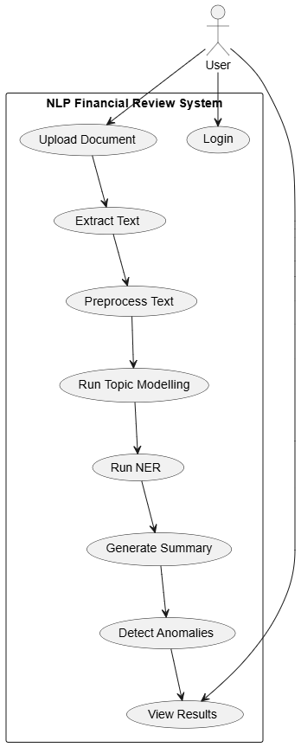
Figure 1 Use Case Diagram
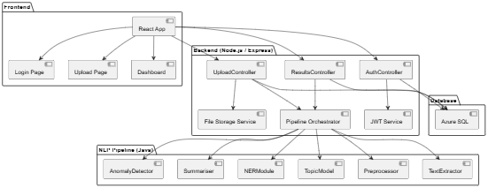
Figure 2 Component Diagram

Data Processing Summary
The system life cycle begins when a user uploads a financial document through the web interface. The text extraction module will then retrieve machine-readable content from the document, followed by tokenisation and cleaning. After this functionality is completed, the text passes through the topic-modelling, entity recognition and summarisation stages. Following this the anomaly detection aspect will assign a traffic light classification to the document before the final output, that being summary, entities and anomaly score, is displayed. The final display will be shown through the React dashboard for the user’s interpretation. This sequential flow ensures that the system had consistency, auditability, and the potential for quantitative evaluation in later testing.

System Architecture & Design
The system architecture for this project will be developed to support the secure handling of financial data, modular linguistic processing and efficient interaction between various system components. The project supports a structured, layered architecture model which comprises of a React-based frontend, Node.js/Express backend, and a Java powered NLP pipeline. As stated in the Project Proposal, this approach to development emphasizes usability, modularity, privacy, and explainability as key design principles. As identified in the literature reviewed, this approach to system creation shows how NLP systems benefit from pipeline-based workflows. This is further shown where workflows separate ingestion, pre-processing, modelling, and anomaly detection in order to minimize error occurrence and maximise interpretability. (Wang et al., 2024a).

Hardware and Software Requirements
The system will be developed using standard hardware which features at least 16 GB of RAM, a multi-core CPU, and SSD storage which will ensure stable performance when running. Although research shows that financial data is more computationally expensive, the chosen algorithms were selected to counter these limitations as they do not require GPU acceleration. The decision to build the system using this developmental approach aligns with the constraints discussed in the Project Proposal. Said constraints included the need for a system deployable on typical enterprise grade hardware without the need for costly infrastructure.
The software environment will consist of a React.js frontend, a Node.js/Express backend, and a Java NLP processing module which uses libraries such as Apache Tika, Apache OpenNLP, and Stanford CoreNLP. The tools selected were chosen for their maturity, stability, and widespread industry adoption. For the text extraction process, the system will optionally interface with Azure Form Recognizer. From the literature reviewed, this form of text extraction has shown to be effective in its handling of multiple column documents with complex layout patterns. (Hegghammer, 2022b). GitHub will be used for version control of the project. This enables a structured collaboration and supports the Agile methodology mentioned in the project proposal. The run time communication will be secured using HTTPS while user authentication is covered by bcrypt and JWT. This approach ensures that the project complies with standard GDPR and Azure data-handling guidelines. (JudithPRA, 2025).

High-Level System Architecture
The high-level architecture design for the system follows a three-layer structure:
- A presentation layer
- An application layer
- An analytical layer
This layered design best aligns with established principles in distributed systems engineering. It ensures modularity, scalability, and maintainability at each stage of the project life cycle. By isolating various functional requirements across the different system layers, the architecture supports the independent scaling of different components. It also enforces secure data flow between each of the three layers and provides a clear separation of concerns. In summary, such a structure will reduce complexity, facilitate testing, and also allow future development to be integrated with minimal disruption.

Presentation Layer
The presentation layer of the system will be implemented using React. This was chosen for its compartment-based architecture, strong ecosystem, and its ability to deliver responsive, dynamic interfaces. It is this layer which will provide the user with the functionality to submit the financial documents, review them, and interact with the system as a whole.
One of the core non-functional requirements was accessibility. With this in mind, the interface will be designed to comply with WCAG 2.1 AA standards, which ensures usability for users with diverse needs. These standards best align with industry practices and guidelines from the Web Accessibility Initiative (WAI). (Initiative (WAI) and Henry, 2005). Beyond this, Reacts’s virtual DOM and its efficiency in rendering mechanisms contribute to performance, which ensures the system remains responsive even under high user load.

Application Layer
The application layer for the system will be implemented using Node.js/Express. These were chosen as they provide a lightweight, event—driven backend framework which is best suited to handling concurrent requests. This layer will be responsible for:
Authentication and Authorization: Implementation will be done using JWT-based stateless sessions. This will reduce the reliance on server-side storage and minimize attack vectors.
Routing and API Management: Functionality will include coordinating the requests between the presentation and analytical layers of the system.
File Handling: This section will handle the secure upload of the financial documents. Validation and preparation of the documents for analysis will also be covered under this functionality.
Security Enforcement: In order to best safe-guard data, controls such as input sanitization, rate limiting, and encryption will be implemented into the system.
The stateless design of the systems backend should enhance the scalability of the system. This will allow for horizontal scaling across multiple instances without there being overhead in relation to session management. This approach will also improve resilience as the individual nodes can be scaled or even replaced without major impact on the user sessions.

Analytical Layer
The NLP pipeline will be hosted on the analytical layer of the system. It is here that the systems core language-processing tasks are performed. Such functions include tokenization, entity recognition, anomaly detection, and summarization which is tailor made to handle financial documents.
The key design features include:
Local Processing: The financial documents are processed locally rather than having them transmitted to an external API. By doing this the risk for data leaks is mitigated. Research shows that privacy is a critical concern in financial NLP deployment. (Badmus, Toromade and Adebayo, 2025).
Ethical Compliance: All the sensitive financial data will remain under the control of the system, aligning with the ethical constraints set out.
Cloud Compatibility: The system will aim to integrate with Microsoft Azure which will enable elastic compute scaling, advanced AI services, and hybrid deployment models. This will ensure portability and extensibility for the system, which allows it to adapt to various workloads.
Hybrid Deployment Strategy: The system design aims to support both on-premises and cloud=based extraction. This would balance the security aspects with scalability.
The analytical layer aims to achieve a balance between security, scalability, and extensibility by combining privacy-preserving local processing with cloud integration. This implementation aims to address the system various non-functional requirements.

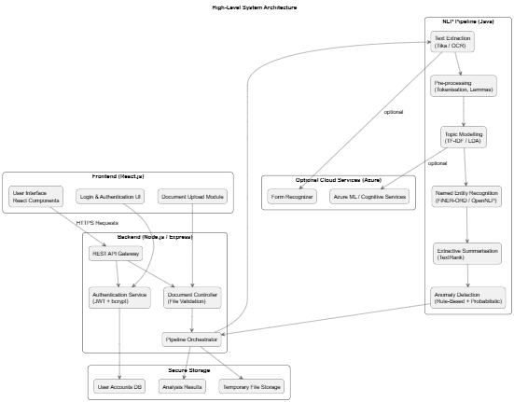
Figure 3 High Level Diagram

Key Components, Functions, and Interactions
Interactions between the various system components will follow a well-defined workflow which will ensure security, modularity, and data integrity. HTTPS will be implemented where the frontend interacts with the backend, never accessing the processing modules directly. The aim of implementing this approach is to reduce the viable attack surface and it also aligns with the advice from the literature reviewed. Such research puts a heavy emphasis on strict separation between the user interface and the processing components. (Shah et al., 2024a).
The systems backend component is what is responsible for handling all incoming requests, validating user credentials, receiving uploaded files, and initiating the document analysis process. Once the uploaded document is accepted by the system, the backend will then create a Document instance. This instance will then be forwarded for extraction and processing. The NLP pipeline itself will consist of several coordinated modules:
- Text extraction
- Pre-processing
- Topic Modelling
- NER
- Summarisation
- Anomaly detection
Each of the modules will produce structured output which will then be passed to subsequent modules. This reflects the pipelines architecture which is often recommended in a natural language system design. (InstituteAdmin, 2025b).
The NLPProcessor, which sequences the operations, will be what controls the interactions between the various modules. The anomaly detection system will be what evaluates the consistency between the extracted entities, summary content, financial terms, and the expected structure of the document. These processes will use a combination of rule-based logic and probabilistic checks. The aim of this hybrid design is to address the liitations of machine-learning anomaly detectors which have been identified in the reviewed literature. (Ji, Dong and Driggs-Campbell, 2022; PricewaterhouseCoopers, 2023b).

Description of System Features and Workflows
Within the system there will be several inter-connected features, each driven by certain domain requirements and adhering to the best practices in financial NLP. The workflow will begin with the uploading of the documents on the frontend, these documents can be in a variety of formats including PDF, DOCX, or XLSX. Once uploaded, the backend will validate the file type, size, and user permissions before the file can be forwarded or extracted. According to the literature reviewed, the extraction accuracy is the most influential factor concerning NLP performance. The system will also incorporate a robust parsing module with a fallback OCR. (Jin et al., 2025).
Methods such as tokenisation, noise removal, stop-word filtering, and lemmatisation will be applied within the pre-processing workflow. These will incorporate a stop-word filtering list which will identify and prevent the elimination of financial terms such as “liability” or “balance”. This is essential as, according to the reviewed literature, it will significantly reduce topic coherence and the accuracy of NER. (Zvornicanin, 2022b).
In order for the system to have the ability to identify recurring issues, topic modelling will be implemented. This process will highlight the high-value themes within the management accounts and the financial statements. Models trained on corpora such as FiNER-ORD will be utilized for the named entity recognition aspect of the system. (Shah et al., 2024a). This will see the extraction of structured financial entities from the uploaded documents. With these features implemented, other tasks within the system will be supported, such as anomaly detection and summarisation.
TextRank will be implemented into the extractive summarisation module to ensure that the generate summaries remain factual and numerically stable. The aim for this section would be to address hallucination issues which were reported in abstractive financial models. (Chae et al., 2024). The document will be evaluated by the anomaly-detection module using a combination of rule-based checks and probabilistic scoring which will be informed by linguistic anomalies.
Code Listing 3 Summarisation Function
# --- Full Financial Document Analysis Endpoint ---
# This endpoint performs complete NLP analysis on financial documents
@app.post("/analyze")
def analyze_document(request: TextRequest):
# Record start time to measure how long processing takes
start_time = time.time()
original_text = request.text

# ========== STEP 1: Preprocess the text ==========
# Clean up the text by removing stopwords but keeping financial terms
cleaned_text = preprocess(original_text)

# ========== STEP 2: Extract Named Entities (NER) ==========
# Use spaCy to find entities like people, organizations, money amounts
processed_document = nlp(original_text)

# Build list of all entities found
all_entities = []
for entity in processed_document.ents:
entity_info = {
"text": entity.text,
"label": entity.label_,
"start_char": entity.start_char,
"end_char": entity.end_char
}
all_entities.append(entity_info)

# ========== STEP 3: Extract Financial Figures ==========
# Use regex + nearby financial context for cleaner, more reliable values
financial_figures = extract_financial_figures(original_text)

# Keep non-money entities for entity panels (financial figures are already separate)
non_money_entities = [entity for entity in all_entities if entity["label"] != "MONEY"]

# ========== STEP 4: Topic Modeling (LDA) ==========
# Find the main topics discussed in the document
from sklearn.feature_extraction.text import ENGLISH_STOP_WORDS

# Split text into sentences
sentences = re.split(r'(?<=[.!?]) +', original_text)

# Clean each sentence
processed_sentences = []
for sentence in sentences:
if sentence.strip(): # Only process non-empty sentences
cleaned_sentence = preprocess(sentence)
processed_sentences.append(cleaned_sentence)

# LDA needs at least 2 documents to work
if len(processed_sentences) < 2:
processed_sentences = [cleaned_text, cleaned_text]

# Create TF-IDF vectors from sentences
all_stopwords = list(custom_stopwords | ENGLISH_STOP_WORDS)
vectorizer = TfidfVectorizer(stop_words=all_stopwords)
tfidf_matrix = vectorizer.fit_transform(processed_sentences)

# Run LDA to find 2 main topics
lda_model = LatentDirichletAllocation(n_components=2, random_state=42)
lda_model.fit(tfidf_matrix)

# Get the top 5 keywords for each topic
topic_words = []
feature_names = vectorizer.get_feature_names_out()

for topic_number, topic_weights in enumerate(lda_model.components_):
# Get indices of top 5 words for this topic
top_word_indices = topic_weights.argsort()[-5:][::-1]
# Convert indices to actual words
top_keywords = [feature_names[index] for index in top_word_indices]
topic_words.append({
"topic": topic_number + 1,
"keywords": top_keywords
})

# ========== STEP 5: Create Summary ==========
summary = textrank_summary(original_text, max_sentences=4)

# ========== STEP 6: Calculate Processing Time ==========
end_time = time.time()
processing_time = end_time - start_time

all_entities.append(entity_info)

# ========== STEP 3: Extract Financial Figures ==========
# Use regex + nearby financial context for cleaner, more reliable values
financial_figures = extract_financial_figures(original_text)

# Keep non-money entities for entity panels (financial figures are already separate)
non_money_entities = [entity for entity in all_entities if entity["label"] != "MONEY"]

# ========== STEP 4: Topic Modeling (LDA) ==========
# Find the main topics discussed in the document
from sklearn.feature_extraction.text import ENGLISH_STOP_WORDS

# Split text into sentences
sentences = re.split(r'(?<=[.!?]) +', original_text)

# Clean each sentence
processed_sentences = []
for sentence in sentences:
if sentence.strip(): # Only process non-empty sentences
cleaned_sentence = preprocess(sentence)
processed_sentences.append(cleaned_sentence)

# LDA needs at least 2 documents to work
if len(processed_sentences) < 2:
processed_sentences = [cleaned_text, cleaned_text]

# Create TF-IDF vectors from sentences
all_stopwords = list(custom_stopwords | ENGLISH_STOP_WORDS)
vectorizer = TfidfVectorizer(stop_words=all_stopwords)
tfidf_matrix = vectorizer.fit_transform(processed_sentences)

# Run LDA to find 2 main topics
lda_model = LatentDirichletAllocation(n_components=2, random_state=42)
lda_model.fit(tfidf_matrix)

# Get the top 5 keywords for each topic
topic_words = []
feature_names = vectorizer.get_feature_names_out()

for topic_number, topic_weights in enumerate(lda_model.components_):
# Get indices of top 5 words for this topic
top_word_indices = topic_weights.argsort()[-5:][::-1]
# Convert indices to actual words
top_keywords = [feature_names[index] for index in top_word_indices]
topic_words.append({
"topic": topic_number + 1,
"keywords": top_keywords
})

# ========== STEP 5: Create Summary ==========
summary = textrank_summary(original_text, max_sentences=4)

# ========== STEP 6: Calculate Processing Time ==========
end_time = time.time()
processing_time = end_time - start_time

# ========== Return Results ==========
return {
"entities": non_money_entities,
"financial_figures": financial_figures,
"topics": topic_words,
"summary": summary,
"processing_time_seconds": round(processing_time, 3),
"input": original_text
}

# Run LDA to find 2 main topics
lda_model = LatentDirichletAllocation(n_components=2, random_state=42)
lda_model.fit(tfidf_matrix)
# Get the top 5 keywords for each topic
topic_words = []
feature_names = vectorizer.get_feature_names_out()
for topic_number, topic_weights in enumerate(lda_model.components_):
# Get indices of top 5 words for this topic
top_word_indices = topic_weights.argsort()[-5:][::-1]
# Convert indices to actual words
top_keywords = [feature_names[index] for index in top_word_indices]
topic_words.append({
"topic": topic_number + 1,
"keywords": top_keywords
})
# ========== STEP 5: Create Summary ==========
summary = textrank_summary(original_text, max_sentences=4)
# ========== STEP 6: Calculate Processing Time ==========
end_time = time.time()
processing_time = end_time - start_time
# ========== Return Results ==========
return {
"entities": non_money_entities,
"financial_figures": financial_figures,
"topics": topic_words,
"summary": summary,
"processing_time_seconds": round(processing_time, 3),
"input": original_text
}

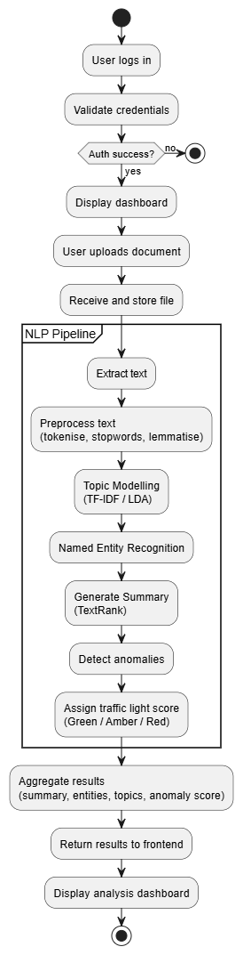
Figure 4 Activity Diagram

Design and Implementation Constraints
There were several factors that influenced the design constraints of the project such as privacy, explainability, computation, and time. With the nature of the financial datasets being sensitive information, external API-based processing could not be used. (Du et al., 2025). Adhering to this constraint aligns with concerns expressed in the Azure OpenAI governance research. (mrbullwinkle, 2025b). Here it was emphasized the implementation of strict data isolation and privacy controls within a system. Based on this, the system will rely on local processing meaning all the NLP libraries will need to be lightweight, open-sourced, and compatible with offline execution.
Explainability, which takes the form of summarization in the system, was another constraint that needed to be addressed. The system users needed to be able to understand why the system produced the summary it did. Literature reviewed showed the risk of black-box ML systems, which reduced transparency when auditing. (Wang et al., 2024b). With this in mind, this project will aim to implement interpretable models that will make the processes more user friendly.
As with any project, there will be limitations as to what resources can be used during development. The aim here will be to use all available resources and implement them to their fullest potential so as to get the best results for each segment of the project. With that in mind, time restraints also are a major constraint. Having roughly twelve weeks means sticking to a rigid schedule but even with this there may have to be some sacrifices made. Such sacrifices may be reworking different sections depending on the ease of its implementation.

System Qualities

Maintainability
One of the key architecture goals of this project was ensuring it maintainability. This will be achieved through the separation of the system into a React frontend, Node backend, and Java NLP processor to allow each section to be updated independent of the other. The overall aim of this separation will be to facilitate the replacement or updating of certain segments of the system. If construction of the system goes as planned, the pipeline should support any enhancements with minimal refactoring of modules.

Extensibility
The modular class design of the class of the system is what will be supporting the extensibility of the project. While the plan is to have the NLPProcessor class coordinate execution, individual modules can be upgraded or substituted if the need arises. An example would be if SHAP-explainable ML classifiers were included in the anomaly detection aspect of the system. (Lundberg and Lee, 2017).

Scalability
Scalability within the project will be accomplished via the stateless backend and cloud-compatible pipeline. If time and resources will permit, the system will be deployed in a multi-instance environment such as Azure App Service. This will allow multiple users to submit documents concurrently without impacting the overall performance of the system as a whole. Through structured error handling, strict input validation, and fallback mechanisms, reliability can be achieved within the system.

Security Protocols and Considerations
Due to the nature of the documents being uploaded to the system, security is an essential design requirement. All system users will have their credentials hashed using bycrypt before being stored. This will prevent plaintext expose in the even of a database breach. In order to ensure secure, stateless session management, JWT tokens will be implemented. As well as this, all data transmission that takes place between the systems front and back end will be done using HTTPS. To added to this encryption, the backend component of the system will enforce strict access control though role-based authorisation.
The documents will only be temporarily stored and then automatically deleted after the analysis is completed, unless configured otherwise. Due to GDPR-compliance requirements and literature reviewed, no external services will receive the files due to the risks associated. (Badmus, Toromade and Adebayo, 2025). All inputs will also be sanitised, and file types will be restricted to known formats so as to mitigate injection and deserialization risks.

Testing Strategy
Testing is a critical step in any system project. For the purpose of this system a variety of different methods will be utilized. Such methods will include unit, integration, system, usability, and performance testing. The aim of the unit tests will be to validate individual components within the system, such as pre-processor, NER engine, and anomaly detection logic. The integration testing aspect will ensure that the outputs from one module can then be used reliably by another. (InstituteAdmin, 2025b). System testing will evaluate the end-to-end workflow from the user login to anomaly presentation.
As the name suggests, performance testing will access the over performance of the system. This will range from document processing speed to certain other non-functional requirements. The aim is to have a professional from Helix Innovation Partnerships Lid conduct a usability test of system once completed. This has yet to be confirmed however research shows that having real-world expert evaluation is essential for validating any system. (Larusdottir, Bjarnadottir and Gulliksen, 2010).

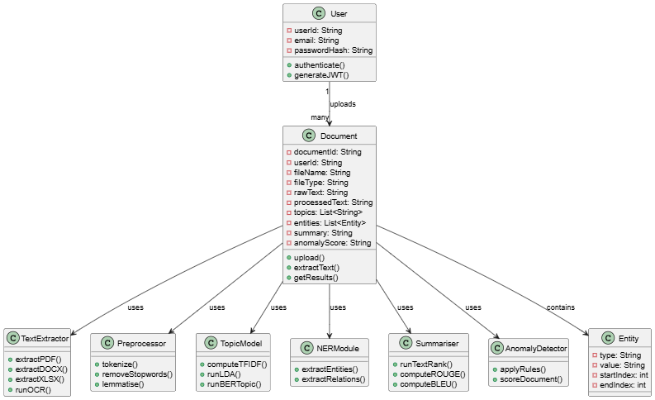
Figure 5 Class Diagram

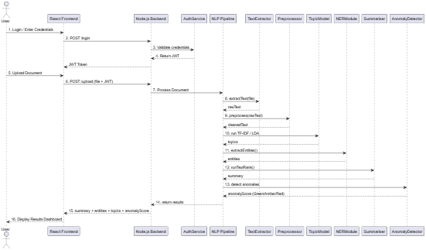
Figure 6 Sequence Diagram

Data Requirements
The primary data requirements for this project define the nature, structure, volume, flow, and constraints associated with the financial documents which will be processed by the system. Due to the sensitive nature of the financial documents, the data requirements must adhere to strict ethical standards, GDPR compliance, and the various constraints outlined in the non-functional requirements. This section will outline the data types used, the structure of data generated within the NLP pipeline, the data storage design, and the data flow.

Data Sources and Characteristics
The primary datasets used for this project will be anonymised financial documents supplied by Helix Innovation Partnerships Ltd. The documents will be a collection of anonymised management accounts, financial summaries, balance sheets, and supporting commentary. The sample documents sent have so far been PDF versions, however the system will have the ability to manage DOCX or XLSX. The documents fall between structured and semi-structured, with multi-column layouts, tables, and footnotes. It is these unique characteristics that represent the challenge identified in the literature reviewed. This challenge is more significant in larger records, which may span multiple pages and contain more tables or columns. (Upadhyay et al., 2025).
Each of the documents utilised in this project were anonymised before being made available to the system. This was to ensure compliance with the ATU ethics requirements and also GDPR restrictions. Research recommended that no personally identifiable information (PII) be present in the documents. Also, the documents should not be shared with or transmitted to any third-party APIs. (Weitzenboeck et al., 2022). By following these guidelines, the project aims to protect and uphold the legal and ethical responsibilities associated with the handling of financial documents.

Data Model and Schema
The documents uploaded to the system will be unstructured which the NLP pipeline will then transform into a structured format. This means that the pipeline module will have three primary schema types:
- Document metadata
- Processed text objects
- Analysis outputs
The documents metadata will include various pieces of information about the financial document. Some of this would be the file name, document ID, file type, upload timestamp, user ID, and storage location. The processed text object will then capture the extracted text, token lists, lemmatised sequence, and the intermediate topic-modelling vectors. Following this the extracted entities will be stored as structured JSON objects containing the entity type, span, token location, and confidence score. This type of structure is similar to that used in pre-established financial NER datasets such as FiNER-ORD for example. (Shah et al., 2024b).
The outputted schema from the anomaly detection model will include information regarding to the anomaly label, rule trigger, confidence score, and a summarised rationale. The aim around this is to present the user with an interpretable output for easy use and understanding. This will also align with guidelines from the research materials regarding the need for transparency in financial anomaly detection. (Almalki and Masud, 2025).
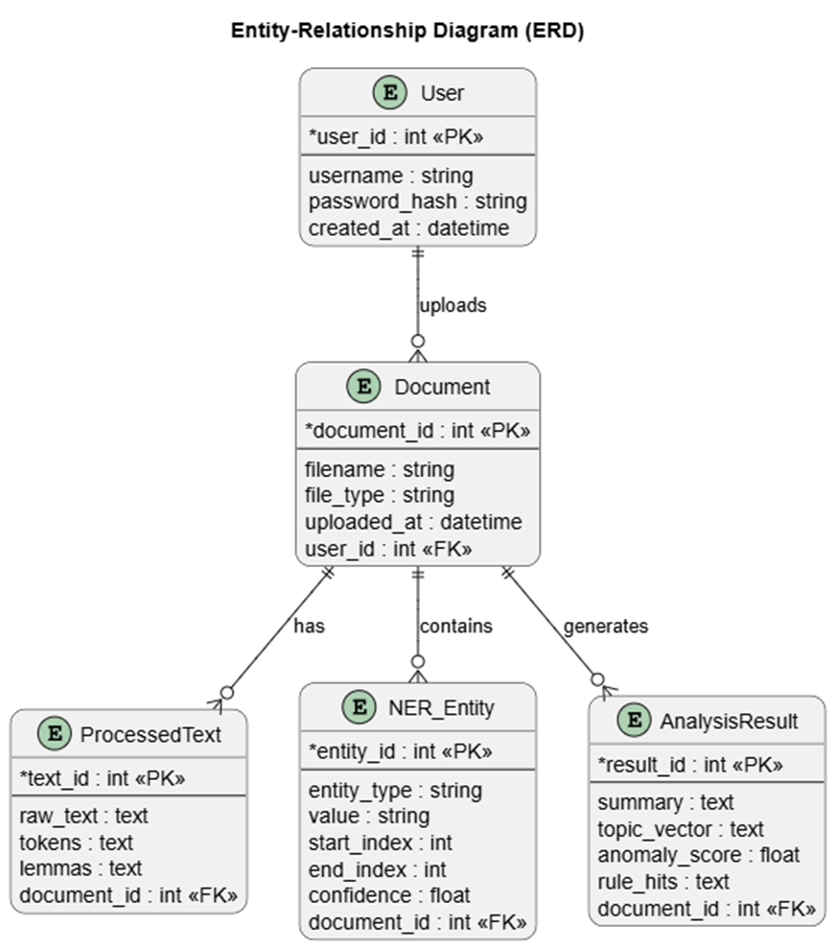
Figure 7 Entity Relationship Diagram

Data Storage Requirements
The system will require storage for three categories of data, user credentials, uploaded files, and analysis outputs. The user credentials will be hashed using bycrypt. This will result in having no plaintext passwords retained within the system, align with the security needs of the system. The uploaded financial documents will only be stored temporarily during the analysis phase of the system life cycle. Following this they will be deleted unless explicitly retained by the system or the user. The aim of this is to reduce the long-term data exposure risks, another key security feature identified in the research materials. The results of the analysis will be stored in a JSON format so as to accommodate re-analysis or user-inspection if needed.
The storage capacity for the system must support the ability for local execution and the ability to perform on a Microsoft Azure cloud environment. This links back to the non-functional requirements stated above and ensures the system will operate under various network conditions. (normesta, no date)

Data Flow
Data flow within the system starts when the user uploads the financial documents at the frontend. The file will be transferred securely, using HTTPS to the system backend where it will be stored temporarily. The file is then transferred to the text extraction module where machine readable text is outputted to the user. Sequentially, the processed text will flow through the NLP pipeline where it will undergo pre-processing, topic modelling, NER, summarisation, and given an anomaly scoring.
At each stage of the system lifecycle intermediate data representation are created, with only the final outputs being returned to the frontend. Modular data flow and minimal coupling between stages is the aim when designing this section. (Garlan and Shaw, 1993). The results will be displayed on the system frontend via React. This will allow the user to review the generated summaries, the entities, and the anomaly indicators.
The aim is to create build the data flow so that it moves in a strictly unidirectional way, for the benefit of user safety. This can be seen demonstrated in Figure 8 below. The aim is to have no data exit the system environment or interact with an external API, aligning with the compliance guidelines set out.
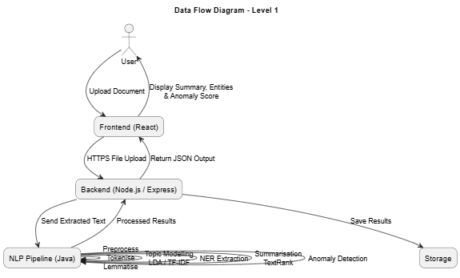
Figure 8 Data Flow Diagram

Data Volume and Performance Constraints
The system will be aimed to small to medium documents, roughly 0.5 – 5 MB. These are the typical sizes for financial documents and management reports. The processing requirements for the system aims to be in under three seconds for the small documents, as stated in the system non-functional requirements. The overall design of the system will ensure that there will be minimal overhead as the system will only perform essential functions related to NLP.
The chosen algorithms will allow the system to remain in a preformatted configuration without the need for GPU acceleration. This aligns with the reviewed literature which shows that lighter-weight NLP pipelines are more suited for analysing the financial documents, especially when reliability and understanding are significant over the need for any deep learning accuracy. (Adedoyin Tolulope Oyewole et al., 2024).

Data Privacy, Ethics, and Security Requirements
Strict data handling rules govern this project as, even though they are anonymised, the system will be handling real financial documents. No document will be transferred to any external services, with the exception of within the Azure environment. To ensure the data does not move beyond the environment, local processing will be the primary mode. This follows the standards and practices defined within the literature reviewed which highlights the risks of transferring financial documents to APIs. (Almalki and Masud, 2025).
The store documents will be encrypted and transmitted via HTTPs. Users will be required to be authenticated before accessing the system so as to comply with GDPR guidelines. Adhering to these guidelines not only ensures the system not only follows industry standards but also follows the ATU ethic guidelines.

Data Quality Requirements
In order to achieve the most accurate results in relation to topic modelling, NER, and summarisation, high quality data is essential. With this, there are a number of points to be considered, such as:
- The extracted text must contain minimal OCR noise.
- The tables and multi-column text, if present, must be preserved.
- Document-relevant terms must be retained at the pre-processing stage.
- A finance-aware list must be implemented with stopword removal.
In the studies reviewed it showed that poor pre-processing will degrade topic coherence score and also reduce the NER precision within the system. (Rahman et al., 2025).

Implementation
The implementation outlines the approach taken when completing this project. The primary objective was to build a system that was clear, realistic, and a technically justified roadmap that translated the design into a fully function prototype. The aim was to have the system design align with the privacy, reproducibility, and ethical guidelines which are relevant to the financial document analysis.

Implementation Approach and Development Methodology
The implementation followed an iterative Agile approach. Agile was chosen for the project development due to its incremental features. These increments are verified through testing, then refined over a series of sprints. Another reason for choosing this model was it ability to handle the integration of multiple technologies across different runtime environments.
The project development was tracked and managed using GitHub. Features such as branches, pull requests, and semantic commit messages proved to be instrumental for traceability and maintainability throughout the implementation. GitHub also aligns with the best practices set out in software development and also the guidelines set out for the project itself. (Git Best Practices – How to Write Meaningful Commits, Effective Pull Requests, and Code Reviews, 2022).
A weekly sprint cycle was adopted for the implementation aspect of the project. Each cycle had distinct deliverables, for example document extraction, NER module integration, and anomaly rule development. At the conclusion of each of the sprint cycles, the functional progress was accessed and logged into the project documentation. This went to maintain the project timeline and avoid tie constraints in the other sprint cycles.

Development Environment and Tools
As stated in the design section, the system consists of a three-level technology stack. The frontend of the system was developed using React, Node.js/Express for the backend, and a Java/Python NLP pipeline. This separation ensures the system is modular, that testing is feasible, and that the system aligned with the architecture design which was defined earlier.
React.js was used to create the frontend environment for the system. This made use of various functional component within the React library, such as Hooks and sematic HTML.
Figure 9 React Imports
The design elements of the system aimed to cover the accessibility requirements of the project. These were supported through the WCAG-aligned design choices which include ARIA labels and implementing proper colour contrast. (ARIA: aria-label attribute - ARIA | MDN, 2025).
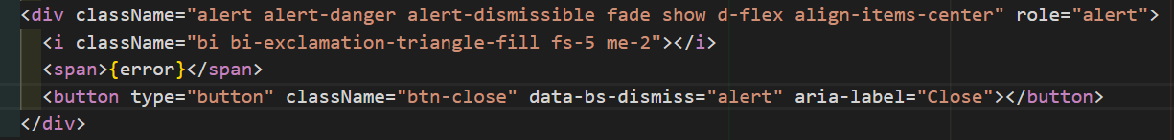
Figure 10 ARIA label
The backend functionality made use of Node.js and Express in order to create lightweight REST endpoints, implement authentication, and coordinate communication with the NLP pipeline.
The security measures put in place consisted of bycrypt hashing and JWT authentication. These features aligned with GDPR and the expectations which surround financial data governance. In addition to this, each of the data files are scheduled to automatically delete themselves from the database after six months. (Jamaludin, no date).
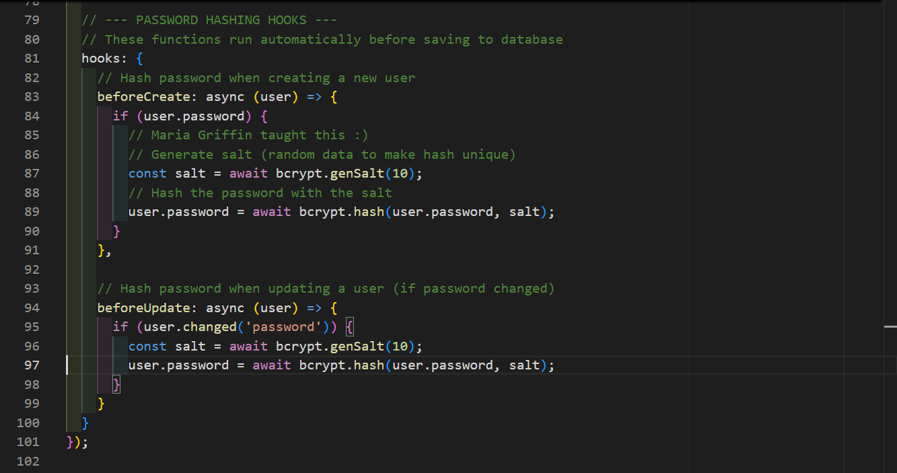
Figure 11 Password Hashing
The NLP pipeline for the for the project was implemented as a modular Node.js and Python workflow rather than a Java-only stack. Apache Tika, with OCR support via Tesseract, was implemented for robust document extraction. Once processed, extracted text is passed through the dedicated NLP microservice for analysis. This backend layer validates the quality of extracted text, enforces minimum text standards, and also keeps the processing steps isolated. Isolation ensures that each stage can be test and improved independently, aligning with best coding practices.
The analysis stage saw the implementation of financial-domain preprocessing with curated stopword handling. This preserves key accounting and reporting terms. Named Entity Recognition is handled with spaCy while topic modelling is performed with TR-IDF features with LDA.
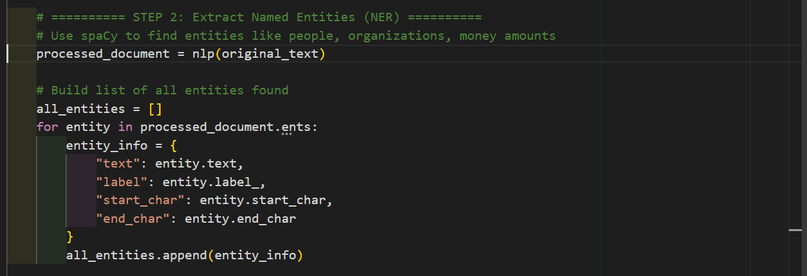
Figure 12 NER Function
The summarisation feature is generated with a sentence-ranking approach with TextRank style for scoring. Financial figure extraction was added using regex with nearby-context checks so that the numeric outputs were more relevant to financial reporting language. This also cut down on the level of noise which slipped through during the extraction process.
def textrank_summary(text, max_sentences=4):
sentences = split_sentences(text)
if len(sentences) == 0:
return text.strip()
if len(sentences) <= max_sentences:
return ' '.join(sentences)

vectorizer = TfidfVectorizer(stop_words='english')
tfidf = vectorizer.fit_transform(sentences)

sim_matrix = cosine_similarity(tfidf)
np.fill_diagonal(sim_matrix, 0.0)

# Normalize rows to make a stochastic matrix
row_sums = sim_matrix.sum(axis=1, keepdims=True)
row_sums[row_sums == 0] = 1.0
transition = sim_matrix / row_sums

n = len(sentences)
scores = np.ones(n) / n
damping = 0.85

for _ in range(30):
scores = (1 - damping) / n + damping * transition.T.dot(scores)

weighted_scores = []
for idx, sentence in enumerate(sentences):
weighted_scores.append((idx, scores[idx] * sentence_financial_weight(sentence)))

top_indices = [idx for idx, _ in sorted(weighted_scores, key=lambda item: item[1], reverse=True)[:max_sentences]]
top_indices.sort()

return ' '.join(sentences[idx] for idx in top_indices)

transition = sim_matrix / row_sums

n = len(sentences)
scores = np.ones(n) / n
damping = 0.85

for _ in range(30):
scores = (1 - damping) / n + damping * transition.T.dot(scores)

weighted_scores = []
for idx, sentence in enumerate(sentences):
weighted_scores.append((idx, scores[idx] * sentence_financial_weight(sentence)))

top_indices = [idx for idx, _ in sorted(weighted_scores, key=lambda item: item[1], reverse=True)[:max_sentences]]
top_indices.sort()

return ' '.join(sentences[idx] for idx in top_indices)

Code Listing 4 TextRank Summary Function

The design of this system followed the modularity and explainability which as covered in the literature reviewed. (Xing and Paul, 2018).
The Azure combability aspect of the project ended up not being implemented due to time constraints. The system itself covers much of what the Azure aspect would have covered so in the end it did not end up being necessary. Possibly in a future iteration the system will be configured to run in an Azure ML.

Planned Codebase Structure
As the project will be stored and saved on GitHub, the repository was broken up into subfolders. Each folder was assigned to each of the major components of the systems. A separate repository was created to store the documentation and research notes. A GitHub project board replaced the MS Project timeline as it was more compatible as the rest of the project was stored on GitHub.
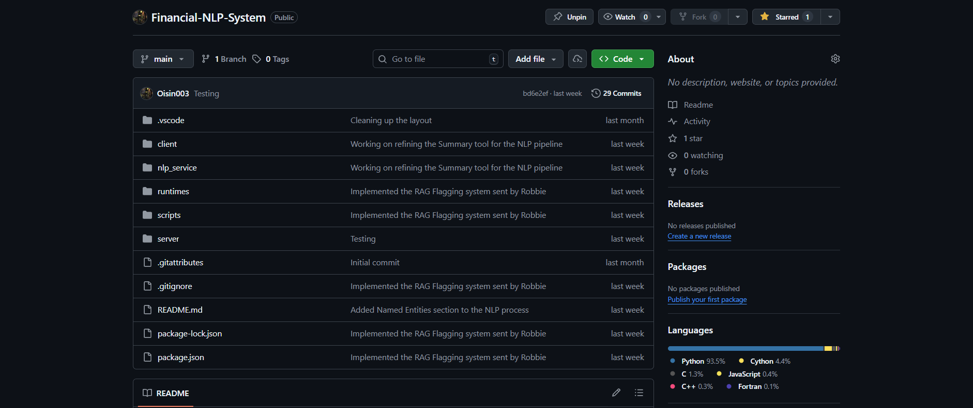
Figure 13 File Structure

Step-by-step Implementation Plan
The system implementation was divided into manageable, sequential sprints which aligned with the technical dependencies.

Sprint 1 – Project Setup, Architecture Scaffolding, and Authentication
Sprint Objective:
Establish the foundational technical environment, repository structure, and core security mechanisms required for subsequent development.
Phase 1: Environment and Repository Setup
- Initialise the GitHub repository with appropriate branching strategy (e.g. main, dev, feature branches).
- Define the high-level folder structure for frontend, backend, and NLP pipeline components.
- Configure development environments for React, Node.js/Express, and Java NLP modules.
- Establish consistent coding standards and commit message conventions to support maintainability.
Phase 2: Backend and Frontend Scaffolding
- Create the basic React application shell, including routing and placeholder views.
- Scaffold the Node.js/Express backend with core middleware (CORS, body parsing, request logging).
- Verify frontend–backend communication through a simple health-check API endpoint.
Phase 3: Authentication and Security Foundations
- Implement secure user authentication using bcrypt for password hashing.
- Integrate JWT-based stateless session management.
- Create protected API routes to ensure that only authenticated users can upload and analyse documents.
- Validate authentication flows using basic test users.
Sprint Deliverables:
- Working frontend and backend skeletons.
- Secure authentication and authorisation mechanism.
- Verified communication between system layers.

Sprint 2 – Document Upload, File Handling, and Extraction Pipeline
Sprint Objective:
Enable secure document ingestion and ensure reliable text extraction from supported file formats.
Phase 1: Secure File Upload and Validation
- Implement document upload endpoints supporting PDF, DOCX, and XLSX formats.
- Enforce file size limits, MIME-type validation, and sanitisation checks.
- Ensure temporary file storage and controlled lifecycle management to reduce data exposure risks.
Phase 2: Text Extraction Integration
- Integrate Apache Tika (and OCR fallback where required) for text extraction.
- Handle multi-page, multi-column, and mixed-content documents.
- Validate extracted text for completeness and readability.
Phase 3: Backend–NLP Pipeline Integration
- Define JSON-based data exchange format between backend and NLP pipeline.
- Ensure extracted text is correctly forwarded for downstream processing.
- Log extraction errors and implement fallback handling for corrupted or unreadable files.
Sprint Deliverables:
- Secure document upload workflow.
- Reliable text extraction pipeline.
- Structured data passed successfully into the NLP layer.

Sprint 3 – Core NLP Pre-processing, Topic Modelling, and NER
Sprint Objective:
Implement the analytical core of the system, focusing on transforming unstructured text into structured, machine-interpretable data.
Phase 1: Text Pre-processing Pipeline
- Implement tokenisation, sentence segmentation, stopword removal, and lemmatisation.
- Introduce finance-aware token retention to preserve domain-specific terminology.
- Benchmark processing times to ensure compliance with performance requirements.
Phase 2: Topic Modelling
- Implement TF-IDF vectorisation and Latent Dirichlet Allocation (LDA).
- Identify dominant financial themes within documents.
- Evaluate topic coherence and adjust parameters as necessary.
Phase 3: Named Entity Recognition (NER)
- Integrate financial-domain NER models to extract entities such as monetary values, dates, organisations, and reporting periods.
- Convert NER outputs into structured JSON objects.
- Validate entity accuracy against sample documents.
Sprint Deliverables:
- Fully operational NLP pre-processing pipeline.
- Topic modelling results with interpretable outputs.
- Structured financial entity extraction supporting downstream analysis.

Sprint 4 – Summarisation, Anomaly Detection, and Explainability
Sprint Objective:
Enhance analytical depth by generating explainable summaries and detecting potential financial anomalies.
Phase 1: Extractive Summarisation
- Implement TextRank-based extractive summarisation.
- Ensure numerical stability and factual accuracy in generated summaries.
- Prepare summaries for later evaluation using ROUGE and BLEU metrics.
Phase 2: Rule-based Anomaly Detection
- Define interpretable anomaly rules aligned with financial domain expectations.
- Implement traffic-light classification (Green, Amber, Red).
- Associate each anomaly flag with a clear rationale to support explainability.
Phase 3: System Integration and Transparency
- Ensure summarisation and anomaly outputs integrate cleanly with previous NLP stages.
- Verify that all analytical decisions can be traced back to extracted entities or rules.
- Refine outputs to align with explainable AI principles.
Sprint Deliverables:
- Reliable extractive summaries.
- Transparent, rule-based anomaly detection module.
- End-to-end analytical workflow within the NLP pipeline.

Sprint 5 – Testing, Refinement, and Project Consolidation
Sprint Objective:
Stabilise the system, validate requirements, and finalise documentation for submission and evaluation.
Phase 1: Testing and Validation
- Conduct unit testing across frontend, backend, and NLP components.
- Perform integration testing to validate full document processing workflows.
- Execute performance and security testing against defined non-functional requirements.
Phase 2: Usability Review and Refinement
- Review system outputs with respect to clarity, relevance, and usability.
- Refine UI presentation of summaries, entities, and anomaly indicators.
- Address usability feedback and correct identified issues.
Phase 3: Documentation and Final Review
- Finalise technical documentation, system diagrams, and code comments.
- Ensure traceability between requirements, implementation, and testing outcomes.
- Prepare the system for final demonstration and academic assessment.
Sprint Deliverables:
- Fully tested and stable prototype.
- Complete documentation and evaluation readiness.
- System aligned with all functional and non-functional requirements.
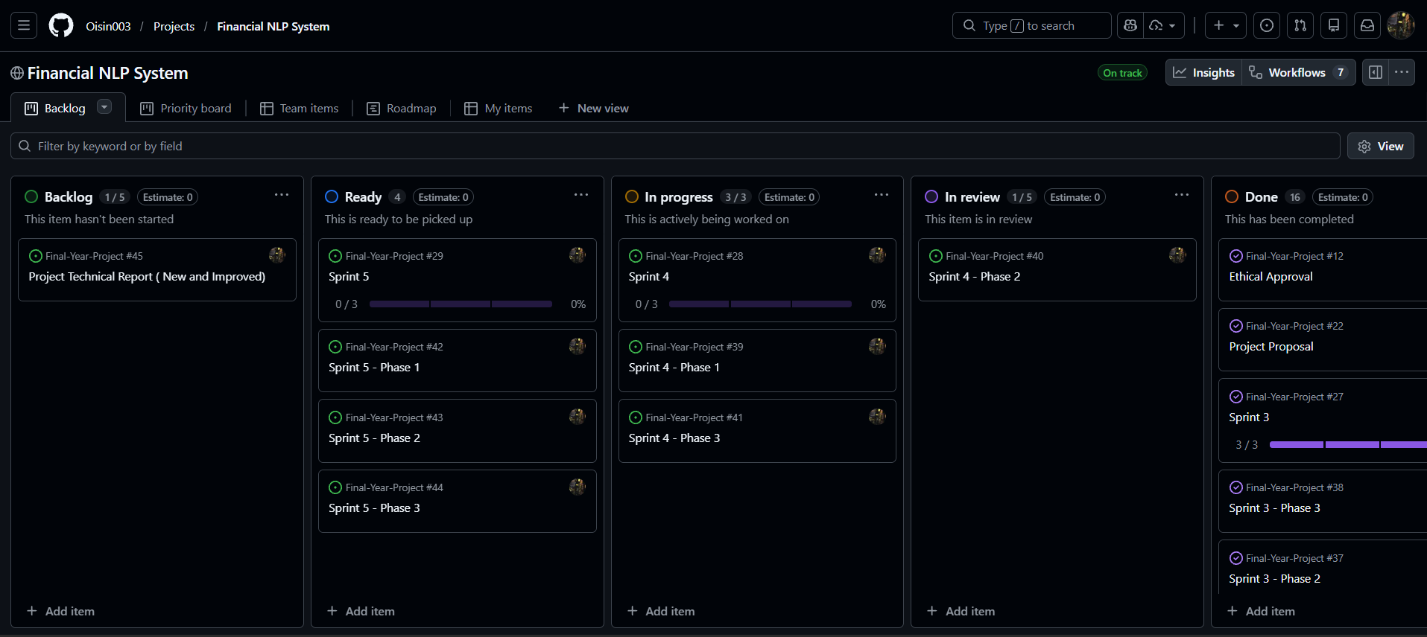
Figure 14 Project Board

Deployment and Runtime Strategy
Originally the deployment was going to be split into two modes, Local and Cloud. The Cloud aspect of the system was sideline in favour of focusing on Local deployment.

Local deployment
In local deployment, the system runs entirely on the user’s machine. This deployment method is best suited for offline testing, iterative deployment, and ensures privacy during the workflow. In addition to this, the package folder will automatically install all dependencies when the system first runs. This ensures that the system can run on any machine without the user needing to set up an environment.
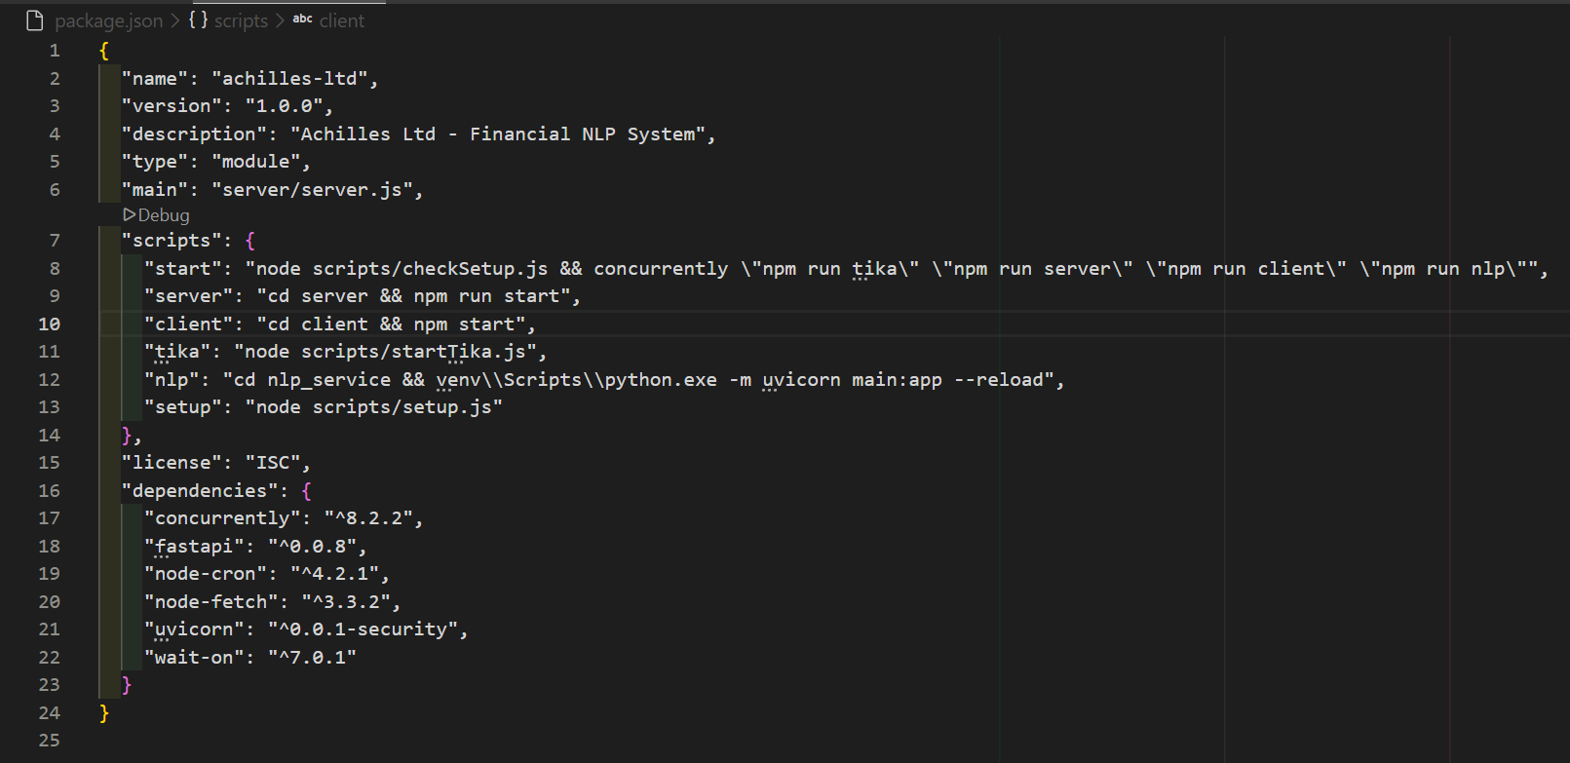
Figure 15 Package File
As stated, the backend section hosts the NLP pipeline. This allows for implementation and extraction without the need for external services. This deployment method also ensures that the financial data, which is sensitive in nature, does not leave the constraints of the system and remains isolated.

Cloud Deployment
If time had allowed, the system would have been able to support deployment to the cloud via Azure App Services. This mode of deployment would have the NLP pipeline be containerised and executed within an Azure instance. This would have allowed for elasticity in terms of scaling the project and implementing other Azure services.

Privacy, Security, and Data Governance
As stated, each of the uploaded documents will remain private and confidential. The processing of said documents adheres to GDPR guidelines of data minimisation, purpose limitation, and storage limitation. (Regulation (EU) 2016/679 of the European Parliament and of the Council of 27 April 2016 on the protection of natural persons with regard to the processing of personal data and on the free movement of such data, and repealing Directive 95/46/EC (General Data Protection Regulation) (Text with EEA relevance), 2016). The uploaded documents will be automatically removed from the database after a period of six months.
When handling errors that arise during configuration and setup, the logs excluded the documents content. The aim was to have the logs reference the documents IDs rather than the raw text itself.
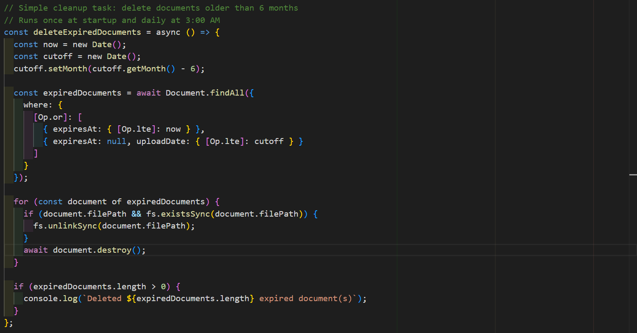
Figure 16 Document Deletion

Error Handling and System Observability
As security is a key concept in this project, the system was developed using defensive techniques. These techniques were implemented to detect invalid user input, invalid file types, or extraction failures.
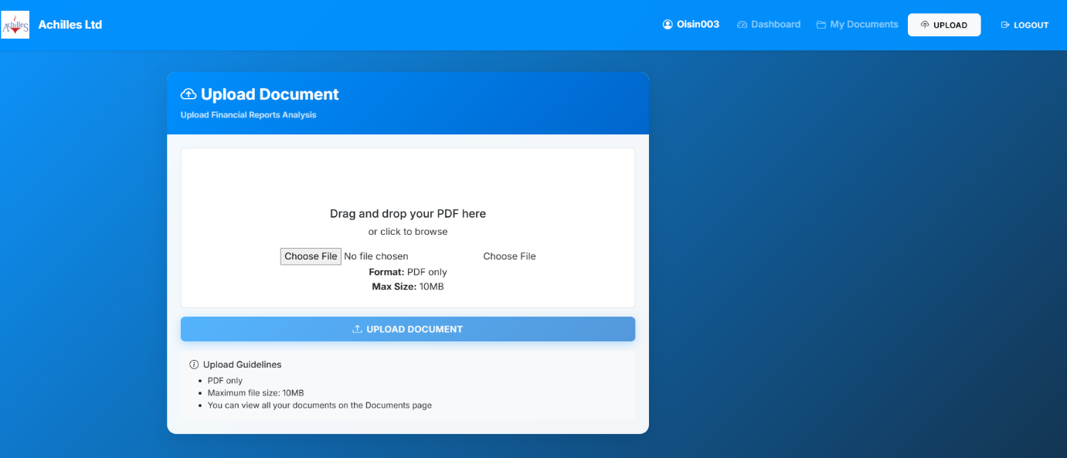
Figure 17 Document Upload
The backend controllers return structured JSON error messages to the user should an error be detected. The NLP aspect of the system supports timeouts and fallback states.
A structured logging framework was developed to generate diagnostic logs. This will support debugging, auditability, and maintainability within the system. It also aligns with best practices for a complex NLP pipeline. (Isaiah, 2026).
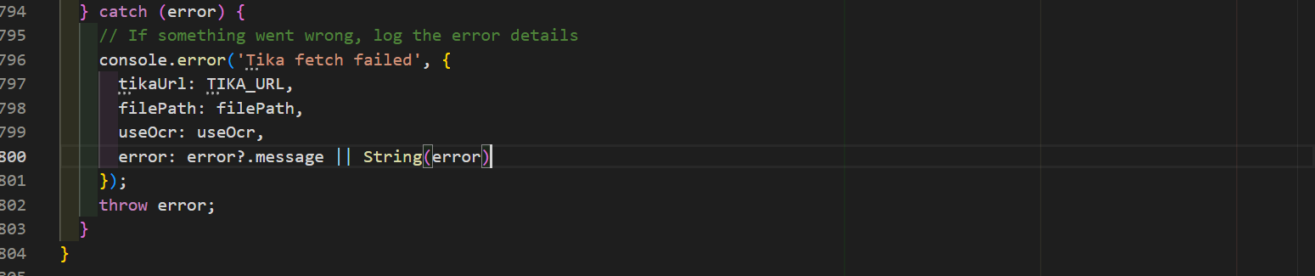
Figure 18 Text Extraction Error Catching

Testing Strategy
A full testing strategy will be covered in Section 6 of this report. Below are a few of the key tests which will be included:
- Unit tests
- Validation of accuracy of extracted information
- Performance testing
- UI validation
These tests will target both the functional and non-functional requirements of the system.

Testing & Evaluation

Conclusion

References
Adedoyin Tolulope Oyewole et al. (2024) “Automating financial reporting with natural language processing: A review and case analysis,” World Journal of Advanced Research and Reviews, 21(3), pp. 575–589. Available at: https://doi.org/10.30574/wjarr.2024.21.3.0688.
Almalki, F. and Masud, M. (2025) “Financial Fraud Detection Using Explainable AI and Stacking Ensemble Methods.” arXiv. Available at: https://doi.org/10.48550/arXiv.2505.10050.
ARIA: aria-label attribute - ARIA | MDN (2025) MDN Web Docs. Available at: https://developer.mozilla.org/en-US/docs/Web/Accessibility/ARIA/Reference/Attributes/aria-label (Accessed: February 25, 2026).
Badmus, O., Toromade, R.O. and Adebayo, A.S. (2025) “(PDF) Embedding AI into ESG-Financial Reporting Frameworks to Advance Trustworthy Non-Financial Disclosures and Data-Driven Investment Decisions,” ResearchGate [Preprint]. Available at: https://doi.org/10.55248/gengpi.6.0725.25165.
Chae, K. et al. (2024) “Mitigating Hallucination in Abstractive Summarization with Domain-Conditional Mutual Information,” Findings of the Association for Computational Linguistics: NAACL 2024, pp. 1809–1820. Available at: https://doi.org/10.18653/v1/2024.findings-naacl.117.
Du, K. et al. (2025) “Natural language processing in finance: A survey,” Information Fusion, 115, p. 102755. Available at: https://doi.org/10.1016/j.inffus.2024.102755.
Garlan, D. and Shaw, M. (1993) “AN INTRODUCTION TO SOFTWARE ARCHITECTURE,” in V. Ambriola and G. Tortora, Series on Software Engineering and Knowledge Engineering. WORLD SCIENTIFIC, pp. 1–39. Available at: https://doi.org/10.1142/9789812798039_0001.
Git Best Practices – How to Write Meaningful Commits, Effective Pull Requests, and Code Reviews (2022) freeCodeCamp.org. Available at: https://www.freecodecamp.org/news/git-best-practices-commits-and-code-reviews/ (Accessed: February 23, 2026).
Hegghammer, T. (2022a) “OCR with Tesseract, Amazon Textract, and Google Document AI: a benchmarking experiment,” Journal of Computational Social Science, 5(1), pp. 861–882. Available at: https://doi.org/10.1007/s42001-021-00149-1.
Initiative (WAI), W.W.A. and Henry, S.L. (2005) WCAG 2 Overview, Web Accessibility Initiative (WAI). Available at: https://www.w3.org/WAI/standards-guidelines/wcag/ (Accessed: November 17, 2025).
InstituteAdmin (2025a) “Text Preprocessing Best Practices: Tokenization to Lemmatization,” Business Analytics Institute, 14 May. Available at: https://businessanalyticsinstitute.com/text-preprocessing-best-practices-tokenization-to-lemmatization/ (Accessed: November 14, 2025).
Isaiah, A. (2026) A Complete Guide to Winston Logging in Node.js | Better Stack Community. Available at: https://betterstack.com/community/guides/logging/how-to-install-setup-and-use-winston-and-morgan-to-log-node-js-applications/ (Accessed: February 25, 2026).
Isreal, O. and Alonge, M. (2025) (PDF) Natural Language Processing for Analyzing Financial Texts in Real-Time, ResearchGate. Available at: https://www.researchgate.net/publication/390493872_Natural_Language_Processing_for_Analyzing_Financial_Texts_in_Real-Time (Accessed: September 26, 2025).
Jamaludin, D. (no date) Build a Secure REST API with Node.js, Express, MongoDB, and JWT – Djamware. Available at: https://www.djamware.com/post/build-a-secure-rest-api-with-nodejs-express-mongodb-and-jwt (Accessed: February 25, 2026).
Ji, T., Dong, R. and Driggs-Campbell, K. (2022) “Traversing Supervisor Problem: An Approximately Optimal Approach to Multi-Robot Assistance.” arXiv. Available at: https://doi.org/10.48550/arXiv.2205.01768.
Jin, Y. et al. (2025) “Multi-Stage Field Extraction of Financial Documents with OCR and Compact Vision-Language Models.” arXiv. Available at: https://doi.org/10.48550/arXiv.2510.23066.
JudithPRA (2025) Reglamento general de protección de datos - Microsoft GDPR. Available at: https://learn.microsoft.com/es-es/compliance/regulatory/gdpr (Accessed: November 19, 2025).
Larusdottir, M.K., Bjarnadottir, E.R. and Gulliksen, J. (2010) “The Focus on Usability in Testing Practices in Industry,” in P. Forbrig, F. Paternó, and A. Mark Pejtersen (eds.) Human-Computer Interaction. Berlin, Heidelberg: Springer, pp. 98–109. Available at: https://doi.org/10.1007/978-3-642-15231-3_11.
Lin, C.-Y. (2004) “ROUGE: A Package for Automatic Evaluation of Summaries,” Text Summarization Branches Out. Barcelona, Spain: Association for Computational Linguistics, pp. 74–81. Available at: https://aclanthology.org/W04-1013/ (Accessed: November 12, 2025).
Lu, Y.-T. and Huo, Y. (2025) “Financial Named Entity Recognition: How Far Can LLM Go?” arXiv. Available at: https://doi.org/10.48550/arXiv.2501.02237.
Lundberg, S. and Lee, S.-I. (2017) “A Unified Approach to Interpreting Model Predictions.” arXiv. Available at: https://doi.org/10.48550/arXiv.1705.07874.
mrbullwinkle (2025a) Data, privacy, and security for Azure Direct Models in Azure AI Foundry - Azure AI services. Available at: https://learn.microsoft.com/en-us/azure/ai-foundry/responsible-ai/openai/data-privacy (Accessed: November 13, 2025).
normesta (no date) Azure Storage encryption for data at rest. Available at: https://learn.microsoft.com/en-us/azure/storage/common/storage-service-encryption (Accessed: November 24, 2025).
Papineni, K. et al. (2002a) “BLEU: a method for automatic evaluation of machine translation,” Proceedings of the 40th Annual Meeting on Association for Computational Linguistics. USA: Association for Computational Linguistics (ACL ’02), pp. 311–318. Available at: https://doi.org/10.3115/1073083.1073135.
Peerdh (2023) Developing A User-friendly Dashboard For Visualizing Anomaly Detection, peerdh.com. Available at: https://peerdh.com/blogs/programming-insights/developing-a-user-friendly-dashboard-for-visualizing-anomaly-detection-results-in-spending-data (Accessed: November 14, 2025).
PricewaterhouseCoopers (2023a) Transforming Conventional Reconciliation and Transaction Monitoring, PwC. Available at: https://www.pwc.com/gx/en/about/analyst-relations/2023/idc-spotlight-pwc-anomaly-detection-platform-2023.html (Accessed: November 14, 2025).
Rahman, M.S. et al. (2025) “AI-Driven Automation of Financial Document Processing: Enhancing Accuracy, Efficiency, and Fraud Detection with OCR, NLP, and Deep Learning,” Library Progress International, pp. 922–928. Available at: https://bpasjournals.com/library-science/index.php/journal/article/view/4183 (Accessed: November 25, 2025).
Regulation (EU) 2016/679 of the European Parliament and of the Council of 27 April 2016 on the protection of natural persons with regard to the processing of personal data and on the free movement of such data, and repealing Directive 95/46/EC (General Data Protection Regulation) (Text with EEA relevance) (2016) OJ L. Available at: http://data.europa.eu/eli/reg/2016/679/oj (Accessed: February 25, 2026).
Shah, A. et al. (2024a) “FiNER-ORD: Financial Named Entity Recognition Open Research Dataset.”
Upadhyay, S. et al. (2025) On the Comprehensibility of Multi-structured Financial Documents using LLMs and Pre-processing Tools. Available at: https://arxiv.org/html/2506.05182v1 (Accessed: November 23, 2025).
Wang, L. et al. (2024a) “Application of Natural Language Processing in Financial Risk Detection.” arXiv. Available at: https://doi.org/10.48550/arXiv.2406.09765.
Weitzenboeck, E.M. et al. (2022) “The GDPR and unstructured data: is anonymization possible?,” International Data Privacy Law, 12(3), pp. 184–206. Available at: https://doi.org/10.1093/idpl/ipac008.
Xing, L. and Paul, M. (2018) “Diagnosing and Improving Topic Models by Analyzing Posterior Variability,” Proceedings of the AAAI Conference on Artificial Intelligence, 32(1). Available at: https://doi.org/10.1609/aaai.v32i1.12033.
Zvornicanin, E. (2022a) “Topic Modeling and Latent Dirichlet Allocation (LDA) | DataScience+,” 30 January. Available at: https://datascienceplus.com/topic-modeling-and-latent-dirichlet-allocation-lda/ (Accessed: October 14, 2025).

Appendix A: Report Structure Example

Project Technical Report
1) Project Overview
- Purpose and objectives of the software
- Scope of the project
- Assumptions, constraints and dependencies
- Definitions and acronyms

2) Requirements
Functional Requirements
- Detailed description of system functions and capabilities
- Input and output specifications
- Data processing operations
- Use cases, user stories (if applicable)
Non-Functional Requirements
- Performance requirements (e.g., response time, throughput)
- Security requirements
- Usability and accessibility standards
- Reliability and availability metrics
- Scalability considerations (if applicable)

3) System Architecture & Design
- Hardware and software requirements (including development and runtime environment)
- High-level system architecture
- Key components/functions/objects and their interactions
- Detailed description of system features, including workflow descriptions.
- Design and implementation constraints
- System qualities (e.g., maintainability, extensibility)
- Security protocols / considerations
- Testing strategy

4) Data Requirements
- Data models and schemas
- Data flow diagrams, class diagram or similar

5) Implementation
- Document the development process
- Code management, version control, etc. (evidence of following best practice)
- Discuss challenges, errors and limitations

6) Testing & Evaluation
- Testing overview / discussing testing requirements
- Functional Testing / Analysis (following testing strategy)
- Results/Evaluation Discussion

7) Conclusion
- Project conclusion/findings
- Limitations
- Future Work

Appendix B: Code Listing / GitHub Project Link
GitHub Project Repo: https://github.com/Oisin003/Final-Year-Project.git
Code Listing 1: PDF Upload Function
Code Listing 2: Text Extraction Function
Code Listing 3: Summarisation Function
Code Listing 4: TextRank Summary Function

